Digital Voice Assistant[A Literature Survey]

Prof. S.V.Shinde
Computer Departement
Pune District Education Association COE Manjari Bk
BCU id :- 52201482373
Mail id:-sashsir@gmail.com
Pune, India
K.D.Darekar
Computer Department
Pune District Education Association COE Manjari
Pune,India
ABC id:-922708398968
darekarkalyani999@gmail.com
M.M.Joshi
Computer Departement
Pune District Education Association COE Manjari Bk
Pune, India
ABC id:-206235116095
maithilijoshi1605@gmail.com

N.A.Tamboli.
Computer Department
Pune District Education Association COE, Manjari
Pune,India
ABC id:-958112361268
tambolinikita12@gmail.com
B.S.Kadam
Computer Departement
Pune District Education Association COE Manjari Bk
Pune, India
ABC id:-520968815930
bhaktikadam151@gmail.com

Abstract— Digital Assistance is computer program specially dedicated to assist user by responding to queries and performing basic tasks. It collects real time observations, which is use for better user experience and learn about the user's behavior. The digital assistant focuses at serving, the following most common and popular utilizations of digital assistant which are, question answering or information retrieval and implementing various local and/or remote services to perform tasks. Digital assistants make a use of advanced artificial intelligence (AI), natural language processing, natural language understanding, and machine learning to learn more about user and their environment in order to provide a personalized, chatty experience. The technologies require for digital voice assistant development are: Speech-To-Text (STT) And Text-To-Speech (TTS), Noise Control, Natural Language Processing (NLP), Natural Language Understanding (NLU), Natural Language Generation (NLG) and Deep learning. Digital assistant system uses microphone to capture the voice input of a user as a primary input. Users make use of a Microphone to capture the spoken input and a speaker to provide responses. The command block contains the main components to navigate the conversation of digital voice assistant with the user. ASR (Automatic speech recognition) is a method recognizer for speech, it forwards the recognition speculation to the NLU. A Natural Language Understanding (NLU) component can extract meaning as commands and associated entities from a pronouncement as text strings. Data providers obtain data using standard dataset from various sources for the better interaction.
Keywords: Artificial Intelligence, machine learning, deep learning, NLP, NLU, Noise control

Introduction

Digital assistant is computer program designed to assist a user by answering questions and performing basic tasks. To interact with a digital assistant, must use a wake word, which device uses to activate the digital assistant. Digital assistant uses advanced Artificial Intelligence, natural language processing and understanding and machine learning. AI to learn as they go and provide a prenasalised, conservational communication. Combining historical information such as purchase preferences, home ownership, location, family size, so on, algorithms can create data models that identify patterns of behaviour and then refine those patterns as data is added. Existing examples of digital assistant are Apple’s Siri, Google assistant, Alexa etc. Digital assistant gathers real time insights, which business can use to continually improve the user’s experience and learn about their customers and employees

Literature review
Artificial Intelligence has been in great use when it comes to day-to-day life. Computer science defines AI research as the study of brilliant agents. In almost any direction one turns today, some form of computer-based information processing technology intrudes, whether to the individual knowingly or not. Artificial Intelligence (AI) has already changed our lifestyle. AI device that perceives its environment and takes actions that maximize its chance of successfully achieving its goals. Input to recommendation algorithm can be a database of user and items and output recklessly will be the recommendations. The user is the input into system by voice or text. This paper presents a new approach for smart search. Overall, in world there are many people who use assistant. The paper presents applications of virtual assistant and describes provocation of applying virtual assistant technology. It is a personalized python speech recognition project, which recognizes the user commands, interacts with them, and completes the tasks accordingly. For instance, it greets the user according to the time and event, plays music, reports the weather, and analyses the weather and suggests if it is okay for the user to go out today, opens all the system applications and folders, creates new folders and changes directories, sends emails and so on.

Voice Assistant(Vision)

First, Voice assistants are intelligent software that responds to voice commands and can run on any device, including smartphones, speakers, desktop/laptop computers, tablets, wearables, gaming consoles, TV consoles, virtual reality (VR) headsets, cars, and IoT devices. Examples include Amazon’s Alexa, Apple’s Siri, Google Assistant, and Microsoft’s Cortana.
This system is designed to be used efficiently on desktops. Personal assistant software improves user productivity by managing routine tasks of the user and by providing information from online sources to the user. VISION is effortless to use. Call the wake word ‘VISION’ followed by the command. And within seconds, it gets executed. Voice searches have dominated over text search. Virtual assistants are turning out to be smarter than ever. Allow your intelligent assistant to make email work for you. Detect intent, pick out important information, automate processes, and deliver personalized responses. This project was started on the premise that there is sufficient amount of openly available data and information on the web that can be utilized to build a virtual assistant that has access to making intelligent decisions for routine user activities

Artificial Intelligence

Artificial Intelligence (AI) has been propelled into the mainstream of learning. AI has many areas like computer science, cognitive and learning sciences, game design, psychology, sociology, philosophy, mathematics, neuroscience, linguistics, defence industry, medicine and education. AI uses logical series of steps called algorithms and advanced cognitive computing technologies to use the techniques of search and pattern matching for providing solutions for the demanded answers. AI is an interdisciplinary field that is used for diagnosis of illnesses, criminal identification and artificial instructions. To develop communication between human and computer, AI possesses the ability to reason while processing a natural language and has different scope of data in terms of the developments in the above mentioned fields. AI, has some other descriptions as well. AI has the ability to comprehend, learn, solve, interpret and execute complex mental process. AI is a subfield of computer science. Natural Language Processing (NLP) is provided for human computer interaction in order to combine human learning and machine reasoning [3 – 5]. NLP is the analysis of linguistic data, most commonly in the form of textual data such as documents or publications, using computational methods.

Technology used in Vision
Vision uses Machine Learning technologies to function. Using ASR (Automatic speech recognition) to transcribe human speech (in this case, short utterances of commands, questions, or dictations) into text. Users speak natural language as voice commands in order to operate the mobile devices (all devices including phones, tabs) and its applications. The idea is to provide high level modelling primitives as integral part of a data model in order to facilitate the representation of real world situations and provide camera for more use of vision.camera in vision is basically used to detect motions and also recognize faces. It is also capable for authorization application.

System Architecture

The architecture of digital voice assistant (Vision)
designed with 3 layers as follows:

1.Client layer

Clients enable the user to access the digital assistant via voice with the following characteristics.

- Commonly Clients uses a microphone to capture the spoken input and a speaker is used to provide responses.

- As an extension to this Clients may also capture input from a specific modality recognizer.
- As an extension, Clients may also capture contextual information, e.g., location.
- As an extension a client may also receive commands to be executed locally.
- As an extension a client may also receive multimodal output to be rendered by a respective modality synthesizer.

2. Command Layer

This is service layer for a client to communicate with command management.
This layer has following characteristics:

- The IPA service acts as an interface between the IPA client and the command management and provider selection service.
- The output from the ASR is forwarded to the Provider Selection Service to get an appropriate meaning.
- Alternatively, the Service may receive multimodal or text input from the client and forwards it directly to the Provider Selection Service to determine meaning.
- Dialog Management receives recorded voice input from the Service and forwards it to the ASR
- Dialog Management makes use of the TTS to generate audio data to be rendered on the Client
- As an extension, it may also provide commands as output to be executed by the IPA Client
- As an extension Dialogs may also return multimodal output or text to be rendered by a respective modality synthesizer on the Client.
- The Dialog Manager is also responsible for a good user experience across the available Dialogs.
- The Command Manager follows the principle to fill in all slots that are known before prompting the user for it.
- The Command Manager also manages the session with a user. Conceptually, multiple sessions can be active in parallel. Commands are governed by Sessions, e.g., to free resources of ASR and NLU engines when a session expires.

- Linguistic phenomena, like anaphoric references and ellipsis are expected to work within a Session. The selected Digital Voice Assistant Provider or the Command Manager may have leading roles for this task.

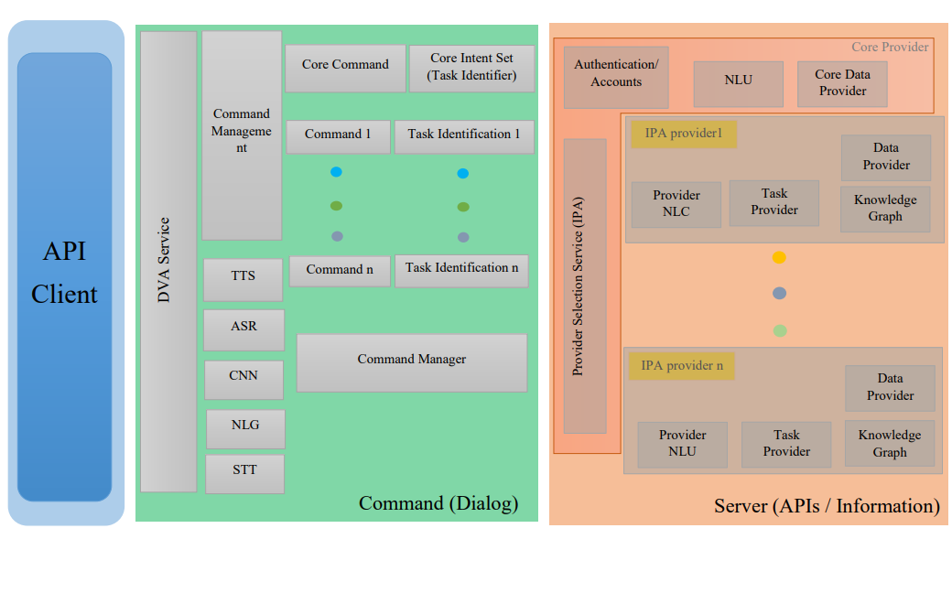

Fig.1.Architecture of Vision

- The Automated Speech Recognizer (ASR) receives audio streams of recorded utterances and generates a recognition hypothesis as text strings. Conceptually, ASR is a modality recognizer for speech.
- The Text-to-Speech (TTS) component receives text strings, which it converts into audio data. Conceptually, the TTS is a modality specific renderer for speech.

3.APIs/Data Layer
A service that provides access to all known Providers. This service also maps the task identifier Sets to the task identifier Sets in the command layer. It has the following characteristics:

- The Provider Selection Service receives input as text strings and returns results as task with all recognized entities from all Providers that are able to reply to the user input along with associated entities.
- In case the Provider Selection Service is called with a preselected Providers only this one will be used.
- Providers the Accounts/Authentication to access them and optionally ASR and TTS capabilities can be added or removed as needed.
- The Provider Selection Service is stateless and always returns the responses.
- Providers along with an identification of the issuing Provider.
- The Provider Selection Service makes use of the Accounts/Authentication to access Provider.
- The Provider Selection Services maps the Provider task identifier Sets to the task Sets known by the Dialog Registry. The mapping must be configured when Providers are added.
- An NLU component that is able to extract meaning as tasks and associated entities from an utterance as text strings for Provider X.
- The Provider NLU may make use of the Data Provider to access local or internal data or access external services.
- The Provider NLU may make use of the Knowledge Graph to derive meaning.
- A knowledge graph to reason about the detected input from the Provider NLU and Data Provider to come up with some more meaningful results.

For better navigation of the user, it can open a map and thus helps in better accessibility.

A sequence diagram shows object interactions arranged in time sequence. It depicts the objects and classes involved in the scenario and the sequence of messages exchanged between the objects needed to carry out the functionality of the scenario.

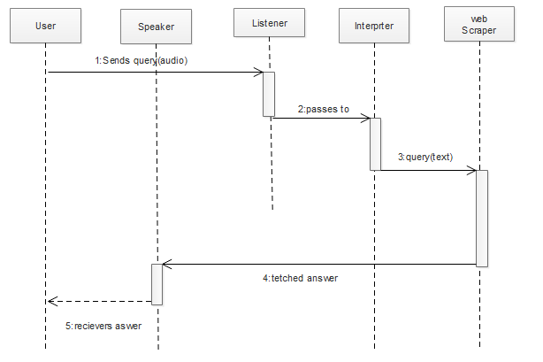

Fig.2.Sequence Diagram

Working Of Vision

Working of vision can be explained in following steps

- Voice Recognition – Whenever a person commands through his/her natural voice, the assistant must be able to convert that analog signal to digital one and then understand what was being said after concatenating the keywords altogether, and finally fixing/obeying the issue/command. This might sound trivial and easy but it is the first step towards reaching the next, since without overcoming the hurdle of country-wise accents, surrounding noises, and specific voices, one cannot successfully establish its working. It also timely learns how its user sounds while speaking specific words. The speech recognition that Vision uses is 80% accurate and has really low error rate.
- Send everything to the servers on the cloud – Vision does not work locally on a mobile device and eats its limited resources, but rather loads everything to the powerful computer servers so as to extend the maximum efficiency and continuously improvise. There is an algorithm that identifies the keywords and go down towards the flowchart branches (conceptually Tree data structure) that best match those keywords, so as to reach out to meaningful conclusions. Best case approach is used to solve such queries. If it fails, it searches for another branch. If it fails here too, it asks whether the user wants results from the Web. It hasn’t reached to the point of conversational App but has numerous conditional statements in its coding that respond according to the user’s action.
- Action based on what was commanded – Here is the most challenging thing. Vision or any other AI assistant you plan to develop must understand what you say. If it fails it might also drag you to potential dangerous situation. For instance, if you said to book a train, it must be capable to understand this and as well interact with other Apps to perform the given task. Plus it must not interact with those sites that aren’t your interest, especially those that involve credit/debit card payment. One might get doomed if the assistant doesn’t serve appropriately.
- The first step, speech to text, essentially converts voice command to a text input that your computer or smartphone gets from typing. Good ‘speech to text’ software like Apple Dictation, Google Docs voice typing and Dragon naturally speaking adjust for ambient noise and variation in voice tone/pitch/accent to provide accurate translation in multiple languages. Science Line explains how the software works:
- The software breaks your speech down into tiny, recognizable parts called phonemes — there are only 44 of them in the English language. It’s the order, combination and context of these phonemes that allows the sophisticated audio analysis software to figure out what exactly you’re saying … For words that are pronounced the same way, such as eight and ate, the software analyses the context and syntax of the sentence to figure out the best text match for the word you spoke. In its database, the software then matches the analysed words with the text that best matches the words you spoke.”
- The second step, text to intent, interprets what exactly does the user mean. For example, if you say “tell me about Paris” in a conversational context, what should the Digital VI interpret as your real intent? Are you asking for latest news about Paris, or flight options to Paris, or current weather in Paris, or news stories about Paris Hilton? Web search engines solve this challenge by ranking answers to the ‘query’ in decreasing order of inferred intent. For Digital VI, the bar is higher as it has to abstract intent from a conversational input, and then respond with one best answer.

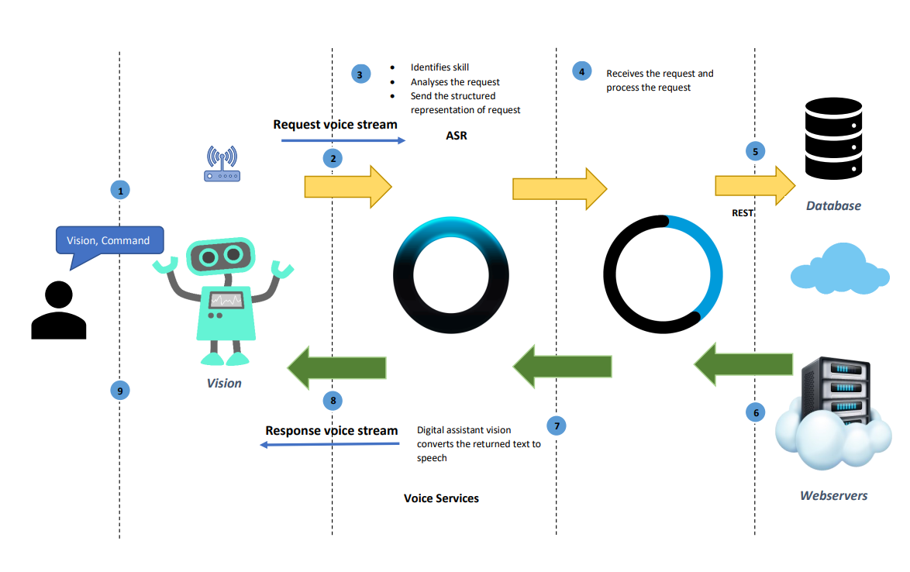
Fig.3.Working of Vision

Modules and algorithm

- Modules
In this proposed system, we have used the multi-model dialogue systems which process two or more combined user input modes, such as speech, head, and body movement in order to design the dedicated digital voice assistant system. We have modified and added some components in the original structure of general dialogue systems, such as ASR Model, Gesture Model, Interaction Model, User Model, Input-Output Model, Inference Engine, Cloud Servers, and Knowledge Base. The following is the structure of the Digital Voice Assistants:

- Knowledge Base
There are two knowledge bases. The first is the online and the second is local knowledge base which include all data and facts based on each model, such as facial and body data sets for gesture modal, speech recognition knowledge bases, dictionary and spoken dialog knowledge base for ASR modal, video and image body data sets for Graph Model, and some user’s information and the setting system.

- Movement / Gesture Model
The Gesture Model analyzes video and image in real-time by using the Gesture Model and extracts frames of the video that collect by the camera and the input model; then it sends those frames and images to the Gesture Model and applications in Cloud Servers for analyzing those frames and images. This model also uses the camera in the input model to read the movements of the human body then it sends all data to the gesture model and applications in Cloud Servers to analyze those frames and images and returning the result.

- ASR (Speech Recognition) Model
The speech recognition model will work in real-time with the microphone in the input model with the ASR model in Cloud Servers to recognize the utterances that a user speaks into a microphone and then convert it to text; then it sends the text to the applications in Cloud Servers to analyze the text and returning the result.

- Interaction Model
This is the main model that will be used to provide interaction between users of the system and the system models by receiving the data from the input model and analyzing the data to send for each model based on its tasks, then returning result that will be used to make the final decision.

- Inference Engine
The inference engine works together with the Interaction Model in the chain of conditions and derivations and finally deduces the outcome. they analyze all the facts and rules, then sorts them before concluding to a solution.

- User Model
This model has all information about the users that will use the system. It can include personal information such as users' names and ages, their interests, their skills and knowledge, their goals and plans, their preferences and their dislikes or data about their behavior and their interactions with the system. All information will be collected by asking the user some questions then storing all answers in the Knowledge Base.

- Input-Output Model
This model will organize the work of all input devices that the system uses to collect the different data from microphone, camera and Kinect. Also, this model includes intelligence algorithms to organize the input information before sending the data to the Interaction Model. This model will receive the final decision from the Interaction Model with an explanation, then it will choose the perfect output device to show the result such data show, speakers or screen based on the result.

- Algorithm

A speech recognition algorithm or voice recognition algorithm is used in speech recognition technology to convert voice to text. To convert text to speech, the ML system must perform the following:
Convert text to words:
Firstly, the ML algorithm must convert text into a readable format. The challenge here is that the text contains not only words but numbers, abbreviations, dates, etc. These must be translated and written in words. The algorithm then divides the text into distinct phrases, which the system then reads with the appropriate intonation. While doing that, the program follows the punctuation and stable structures in the text. Each sentence can be pronounced differently depending on the meaning and emotional tone. To understand the right pronunciation, the system uses built-in dictionaries. If the required word is missing, the algorithm creates the transcription using general academic rules. The algorithm also checks on the recordings of the speakers and determines which parts of the words they accentuate.

The system then calculates how many 25 millisecond fragments are in the compiled transcription. This is known as phoneme processing.

A phoneme is the minimum unit of a language’s sound structure.

The system describes each piece with different parameters: which phoneme it is a part of, the place it occupies in it, which syllable this phoneme belongs to, and so on. After that, the system recreates the appropriate intonation using data from the phrases and sentences. Finally, the system uses an acoustic model to read the processed text. The ML algorithm establishes the connection between phonemes and sounds, giving them accurate intonations. The system uses a sound wave generator to create a vocal sound. The frequency characteristics of phrases obtained from the acoustic model are eventually loaded into the sound wave generator.

Conclusion and future scope

In the near future, voice assistants are also expected to take a more proactive role. Rather than just waiting for user commands, assistants will collect context-specific information and then take the initiative by making helpful suggestions to the user. For example, people can interact with their in-car voice assistants to get information about fuel levels, diagnostics, and service needs or system settings that may need adjustment. So when fuel levels are low, the voice assistant may suggest going to the nearest gas station (with GPS directions if needed).
The future of voice search and assistants is looking bright. With the number of people already seeing how convenient those tools can be and the growing number of devices that use voice recognition. It's clear that the technology will soon be everywhere, and with 5G and improvements in machine learning, voice assistants might at some point become tools we can’t live without.

Acknowledgment

We would like to thank our guide Mr. S.V. Shinde for providing us with useful and valuable comments on the study. This study would not have been possible without their support. All remaining errors, if any, are our responsibility. The usual disclaimer applies

Refrences

[1] R. Belvin, R. Burns, and C. Hein, “Development of the HRL route navigation dialogue system,” in Proceedings of ACL-HLT, 2001, pp. 1–5.
[2] V. Zue, S. Seneff, J. R. Glass, J. Polifroni, C. Pao, T.J.Hazen,and L.Hetherington, “JUPITER: A Telephone Based Conversational Interface for Weather Information,” IEEE Transactions on Speech and Audio Processing, vol. 8, no. 1, pp. 85–96, 2000.
[3] M. Kolss, D. Bernreuther, M. Paulik, S. St¨ucker, S. Vogel, and A. Waibel, “Open Domain Speech Recognition & Translation: Lectures and Speeches,” in Proceedings of ICASSP, 2006.
[4] D. R. S. Caon, T. Simonnet, P. Sendorek, J. Boudy, and G. Chollet, “vAssist: The Virtual Interactive Assistant for Daily Homer-Care,” in Proceedings of pHealth, 2011.
[5] Crevier, D. (1993). AI: The Tumultuous Search for Artificial Intelligence. New York, NY: Basic Books, ISBN 0-465-02997-3. [6] Sadun, E., &Sande, S. (2014). Talking to Siri: Mastering the Language of Apple's Intelligent Assistant. Que Publishing.

[6] T. Ammari, J. Kaye, J. Y. Tsai, and F. Bentley. “Music, Search, and IoT: How people (really) use voice assistants,” ACM Trans. Comput. - Hum. Interact., vol. 26.3, pp. 1-28, 2019.
[7] Blog.google, ‘This Year’s Founders’ Letter’, 2016. [Online].Available: https://www.blog.google/topics/inside-google/this-yearsfounders-letter/ [Accessed: 15- Oct- 2020].
[8] S. Zuboff, “Big other: surveillance capitalism and the prospects of an information civilization,” J. Inf. Technol., vol. 30.1, pp. 75-89, 2015.
[9] Saadman Shahid Chowdury, Atiar Talukdar, Ashik Mahmud, Tanzilur Rahman Domain specific Intelligent personal assistant with bilingual voice command processing IEEE 2018.
[10] Polyakov EV, Mazhanov MS, AY Voskov, LS Kachalova MV, Polyakov SV ³Investigation and development of the intelligent voice assistant for the IOT using machine learning Moscow workshop on electronic technologies, 2018.
[11] Khawir Mahmood, Tausfer Rana, Abdur Rehman Raza Singular adaptive multi role intelligent personal assistant (SAM-IPA) for human computer interaction International conference on open-source system and technologies,2018.
[12] M. McTear .2016. The Dawn of the Conversational Interface. Springer International Publishing Switzerland 2016 [8] CM Research: High quality research requires investment 2016.
[13] Y. Nung, A. Celikyilmaz.Deep Learning for Dialogue Systems. Deep Dialogue...
[14] Amazon. Amazon Lex is a service for building conversational interfaces. https://aws.amazon.com.
[15] Microsoft. Cortana Intelligence. https://azure.microsoft.com.
[16] B. Marr. The Amazing Ways Google Uses Deep Learning AI. https://www.forbes.com..
[17] K. Wagner. Facebook's Virtual Assistant 'M' Is Super Smart. It is Also Probably a Human. https://www.recode.com.

